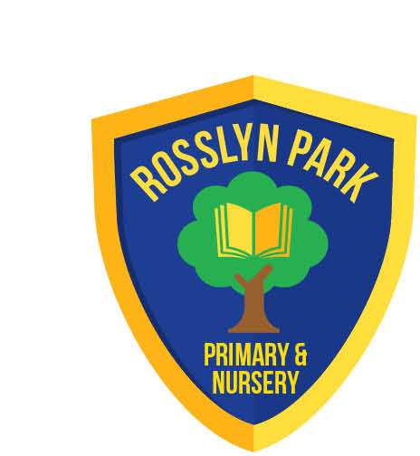
Rosslyn Park
Primary & Nursery School
Executive Head Teacher: Mr Scott Mason
Head of School: Mr Matt Barnham
Amesbury Circus, Aspley, Nottingham. NG8 6DD
Tel: (0115) 915 3266
Email: admin@rosslyn.nottingham.sch.uk

www.rosslyn.nottingham.sch.uk

Dear Parents/Carers,

Happy New Year!
I hope you and your families enjoyed a restful and joyful Christmas break.

As we settle into January, the colder weather has certainly made its presence known. We will continue to monitor conditions closely and make any necessary adjustments to outdoor activities but unfortunately, we have been unable to go outside at break and lunch so far this week due to the sub-zero temperatures.

Due to the cold weather, we have had a number of parents contact the school office asking if school is open. In the unlikely event of school having to close, you will receive an email and an Arbor app message. Otherwise, you should assume that school is open as normal.

Staffing
Some of you will be aware that we have some new members of staff joining us at the start of the Spring term, we welcome Mrs Layton as our new Phase Leader for Years 3 and 4, teaching in Year 3 and Miss Gunson who will be teaching in Year 1.

Miss Potts-Perkins has been promoted to Phase Leader for Years 1 and 2 and has moved classes to teach in Year 2. Mrs Passmore has been promoted from Phase Leader to become our new Assistant Head Teacher.

Parent Survey
Thank you to those parents who completed the parent survey before Christmas. Your responses will be shared with staff, governors and Transform Trust. The school is viewed positively by parents across most core areas of school life. This includes: children’s happiness, safety, learning support and enrichment opportunities.

However, one of the questions we asked you about was school communication – some of you expressed that this is an area that school can do better in – particularly with regards to communication from school being timely and sharing more about what the children have been learning. This is something we will aim to improve as we go through the year.

If you have any questions or concerns as we begin the new term, please don’t hesitate to get in touch. Senior Leaders will be on the playground at the beginning and end of the school day whenever possible if you have any questions or concerns.

Yours Sincerely

Mr M Barnham

Head of School

