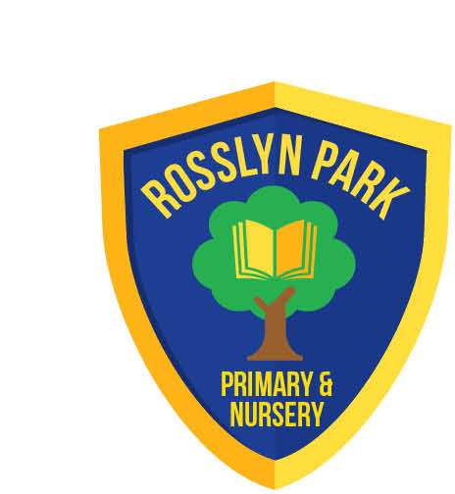
Rosslyn Park
Primary & Nursery School
Executive Head Teacher: Mr Scott Mason
Head of School: Mr Matt Barnham
Amesbury Circus, Aspley, Nottingham. NG8 6DD
Tel: (0115) 915 3266
Email: admin@rosslyn.nottingham.sch.uk

www.rosslyn.nottingham.sch.uk

30th January 2025

Dear Parents/Carers,

Mobile Phones in School
You may be aware that the Department for Education (DfE) has recently strengthened its guidance to schools, advising that all schools should be “mobile phone free environments by default.” This means that pupils should not have access to mobile phones at any point during the school day.
The DfE has also made it clear that Ofsted will now consider how effectively schools implement their mobile phone policies as part of inspections. Ofsted has publicly supported this approach, highlighting that mobile phones can be a significant distraction to learning and may also pose safeguarding risks to pupils.
Rosslyn Park has been a mobile-free school for a number of years, and this is clearly outlined in the school’s Behaviour Policy. Mobile phones are listed as banned items, and the policy is shared with parents each September and published on the school website.
Unfortunately, we have recently seen an increase in pupils bringing mobile phones into school. Our established approach has always been to remind pupils of the rules and then ask parents or carers to collect the phone from the school office.
As a school, our priority is to maintain a calm, focused, and safe learning environment for all pupils, and we appreciate your continued support in helping us to do so.
The updated DfE guidance can be found here:
https://www.gov.uk/government/publications/mobile-phones-in-schools/mobile-phones-in-schools
Yours sincerely,

Mr M Barnham

Head of School

