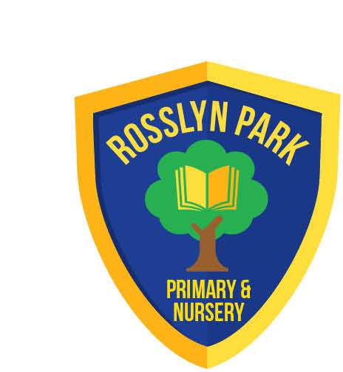
Rosslyn Park
Primary & Nursery School
Executive Head Teacher: Mr Scott Mason
Head of School: Mr Matt Barnham
Amesbury Circus, Aspley, Nottingham. NG8 6DD
Tel: (0115) 915 3266
Email: admin@rosslyn.nottingham.sch.uk

www.rosslyn.nottingham.sch.uk

10th March 2026

Dear Parents/Carers,

Parents Conduct on School Site
The vast majority of our parents and carers consistently demonstrate kindness, patience, and respect while on school premises.
Unfortunately, we have recently witnessed an increase in some parents using foul and abusive language towards pupils, staff and other parents. The Governing Body and Transform Trust will not tolerate conduct of this nature on its premises and will act to protect its staff and pupils.

I have included a copy of the Transform Trust Parent Code of Conduct for your consideration to remind all parents of expectations. The full version of the Code of Conduct is available on the school’s website:

https://primarysite-prod-sorted.s3.amazonaws.com/rosslyn-park-primary-nursery-school/UploadedDocument/767646f7-17ba-4076-8d8e-0a7331859406/341-parent-and-visitor-code-of-conduct-sept-2025.pdf
To help us maintain a calm and supportive environment, we kindly ask that all parents and carers:
- Speak to staff, pupils, and other families politely and respectfully
- Avoid raised voices, inappropriate language, or any form of aggressive behaviour
- Share any concerns with staff in a calm and constructive way so we can support you effectively
Senior Leaders will be on the playground at the beginning and end of the school day whenever possible if you have any questions or concerns.

Yours Sincerely

Mr M Barnham

Head of School

