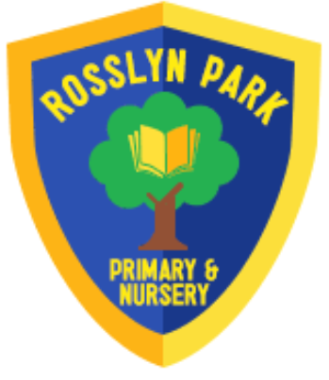

Rosslyn Park Primary School
Rhyme Book
Spring 1


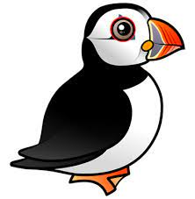

Puffins and Starfish

Chinese Dragon…
(To the tune of "Frere Jacques")
Chinese dragon, Chinese dragon,
Breathing fire, breathing fire,
Happy, happy new year, Happy, happy new year,
Kung hei fat choy,
Kung hei fat choy.
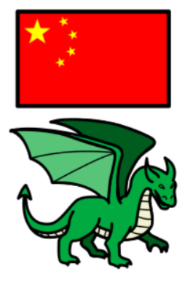

Round and Round the Garden …
Round and round the garden
Like a teddy bear.
One step, two step,
Tickle you under there.

Round and round the garden
Like a teddy bear.
One step, two step,
Tickle you under there.

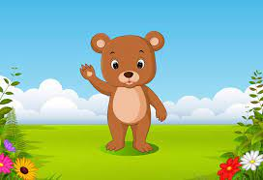



This Little Piggy…
This little piggy went to market
This little piggy stayed home
This little piggy had roast beef
And this little piggy had none
And this little piggy cried wee wee wee all the way home

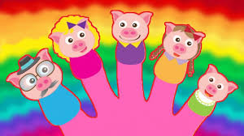



Hey Diddle Diddle…

Hey, diddle, diddle,
The cat and the fiddle,
The cow jumped over the moon;
The little dog laughed
To see such fun,
And the dish ran away with the spoon.

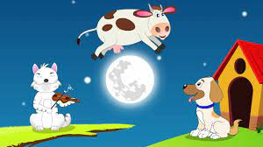



This is the way…
This is the way we brush our teeth
Brush our teeth, brush our teeth
This is the way we brush our teeth
On a warm and sunny morning.

This is the way we wash our face
Wash our face, wash our face
This is the way we wash our face
On a warm and sunny morning.

This is the way we comb our hair
Comb our hair, comb our hair
This is the way we comb our hair
On a warm and sunny morning.

This is the way we put on our clothes
Put on our clothes, put on our clothes
This is the way we put on our clothes
On a warm and sunny morning.

This is the way we stretch up tall
Stretch up tall, stretch up tall
This is the way we stretch up tall
On a warm and sunny morning.



