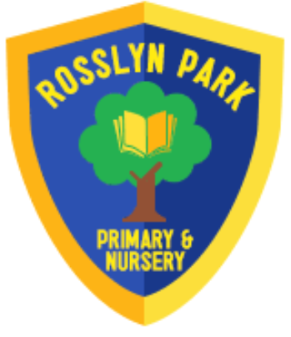

Rosslyn Park Primary School
Rhyme Book
Autumn 2

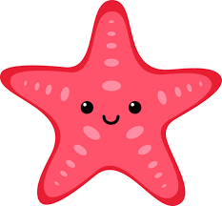
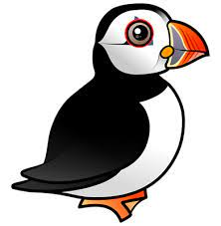

Puffins and Starfish

Hickory Dickory Dock…
Hickory dickory dock. The mouse went up the clock
The clock struck one. The mouse went down, hickory dickory dock
Tick tock, tick tock, tick tock, tick tock
Hickory dickory dock. The snake went up the clock
The clock struck two. The snake went down, hickory dickory dock
Tick tock, tick tock, tick tock, tick tock
Hickory dickory dock. The squirrel went up the clock
The clock struck three. The squirrel went down, hickory dickory dock
Tick tock, tick tock, tick tock, tick tock
Hickory dickory dock. The cat went up the clock
The clock struck four. The cat went down, hickory dickory dock
Tick tock, tick tock, tick tock, tick tock
Hickory dickory dock. The monkey went up the clock
The clock struck five. The monkey went down, hickory dickory dock
Tick tock, tick tock, tick tock, tick tock
An elephant, oh no
Hickory dickory dock. The elephant went up the clock
Oh no
Hickory dickory dock
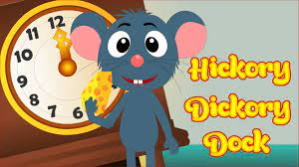


Humpty Dumpty …
Humpty Dumpty sat on a wall.
Humpty Dumpty had a great fall.
All the king’s horses and all the king’s men
couldn’t put Humpty together again.
Humpty Dumpty sat on a wall.
Humpty Dumpty had a great fall.
All the king’s horses and all the king’s men
couldn’t put Humpty together again.
Humpty Dumpty sat on a wall.
Humpty Dumpty had a great fall.
All the king’s horses and all the king’s men
couldn’t put Humpty together again.

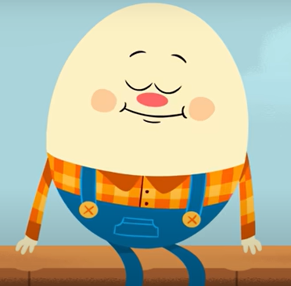


Jack and Jill…
Jack and Jill went up the hill
to fetch a pail of water.
Jack fell down and broke his crown
and Jill came tumbling after.
Jack and Jill went up the hill
to fetch a pail of water.
Jill fell down and broke her crown
and Jack came tumbling after.
La la la la la la la.
La la la la la la.
La la la la la la la.
La la la la la la la.
Jack and Jill went up the hill
to fetch a pail of water.
Carefully they brought it down
and gave it to their mother.
La la la la la la la.
La la la la la la.
La la la la la la la.
La la la la la la la.
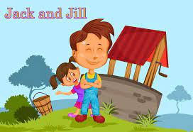


5 Little speckled frogs…
Five little speckled frogs, sat on a speckled log.
Eating some most delicious bugs. Yum Yum.
One jumped into the pool, where it was nice and cool.
Now there are four green speckled frogs.
Glub Glub.
Four little speckled frogs, sat on a speckled log.
Eating some most delicious bugs. Yum Yum.
One jumped into the pool, where it was nice and cool.
Now there are three green speckled frogs.
Glub Glub.
Three little speckled frogs, sat on a speckled log.
Eating some most delicious bugs. Yum Yum.
One jumped into the pool, where it was nice and cool.
Now there are two green speckled frogs.
Glub Glub.
Two little speckled frogs, sat on a speckled log.
Eating some most delicious bugs. Yum Yum.
One jumped into the pool, where it was nice and cool.
Now there is one green speckled frog.
Glub Glub.
One little speckled frog, sat on a speckled log.
Eating some most delicious bugs. Yum Yum.
One jumped into the pool, where it was nice and cool.
Now there are no green speckled frogs.
Glub Glub.

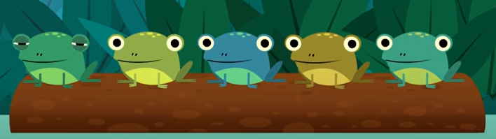

The wheels on the bus…
The wheels on the bus go round and round. Round and round. Round and round.
The wheels on the bus go round and round. Round and round.
The door on the bus goes open and shut. Open and shut. Open and shut.
The door on the bus goes open and shut. Open and shut.
The wipers on the bus go swish swish swish. Swish swish swish. Swish swish swish.
The wipers on the bus go swish swish swish. Swish swish swish.
The horn on the bus goes beep beep beep. Beep beep beep. Beep beep beep.
The horn on the bus goes beep beep beep. Beep beep beep.
The people on the bus go up and down. Up and down. Up and down.
The people on the bus go up and down. Up and down.
The babies on the bus go, “Wah wah wah. Wah wah wah. Wah wah wah.”
The babies on the bus go, “Wah wah wah. Wah wah wah.”
The mommies on the bus go, “Shhh shhh shhh. Shhh shhh shhh. Shhh shhh shhh.”
The daddies on the bus go, “Shhh shhh shhh. Shhh shhh shhh.”



