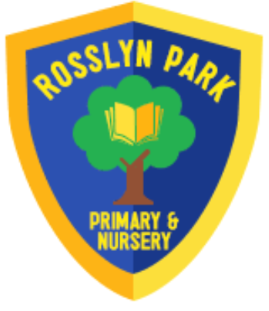

Rosslyn Park Primary School
Rhyme Book
Autumn 2


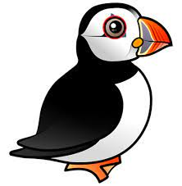

Puffins and Starfish
If you’re happy and you know it…
If you're happy and you know it, clap your hands!
If you're happy and you know it, clap your hands!
If you're happy and you know it and you really want to show it
If you're happy and you know it, clap your hands!

If you're happy and you know it, stomp your feet!
If you're happy and you know it, stomp your feet!
If you're happy and you know it and you really want to show it
If you're happy and you know it, stomp your feet!

If you're happy and you know it, shout hurray!
If you're happy and you know it, shout hurray!
If you're happy and you know it and you really want to show it
If you're happy and you know it, shout hurray!
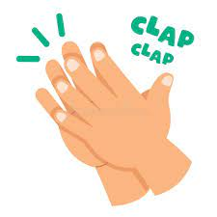



Pat- a- cake…

Pat-a-cake, pat-a-cake baker's man
Bake me a cake as fast as you can
Pat it and prick it and mark it with "B"
Put it in the oven for baby and me

Pat-a-cake, pat-a-cake baker's man
Bake me a cake as fast as you can
Pat it and prick it and mark it with "B"
Put it in the oven for baby and me
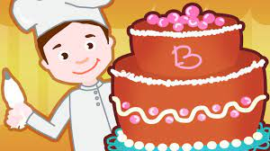

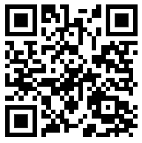

Head Shoulders Knees and Toes…

Head, shoulders, knees and toes, knees and toes.
Head, shoulders, knees and toes, knees and toes.
And eyes and, ears and, mouth and nose.
Head, shoulders, knees and toes, knees and toes.

Head, shoulders, knees and toes, knees and toes.
Head, shoulders, knees and toes, knees and toes.
And eyes and, ears and, mouth and nose.
Head, shoulders, knees and toes, knees and toes.

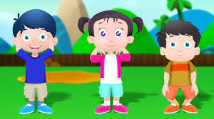



Row Row Row Your Boat…

Row, row, row your boat
Gently down the stream
Merrily merrily, merrily, merrily
Life is but a dream
Row, row, row your boat
Gently down the stream
If you see a crocodile don’t forget to scream!
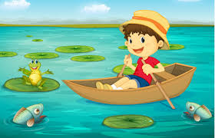



Miss Polly had a Dolly…

Miss Polly had a dolly who was sick, sick, sick
And she called for the doctor to come quick, quick, quick
The doctor came with his bag and his hat
And he knocked at the door with a rat-a-tat-tat
He looked at the dolly and he shook his head
And he said, "Miss Polly, put her straight to bed"
He wrote on a paper for a pill, pill, pill
I'll be back in the morning if the baby's still ill.

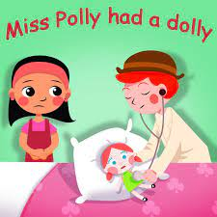



Jumping up and down on the big red tractor…

Jumping up and down on the big red tractor, jumping up and down on the big red tractor, jumping up and down on the big red tractor, bringing all the hay (hey!)

Jumping up and down on the big red tractor, jumping up and down on the big red tractor, jumping up and down on the big red tractor, bringing all the hay (hey!)
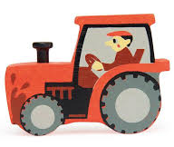


Wind the bobbin up…
Wind the bobbin up.
Wind the bobbin up.
Pull, pull, clap, clap, clap.
Wind it back again.
Wind it back again.
Pull, pull, clap, clap, clap.
Point to the ceiling.
Point to the floor.
Point to the window.
Point to the door.
Clap your hands together, 1, 2, 3.
Put your hands upon your knee.




